**19.TM using simulator to perform addition of ‘aa’ and ‘aaa’**

**AIM:** Todesign TM using simulator to perform addition of ‘aa’ and ‘aaa’

**TRANSITION DIAGRAM:**

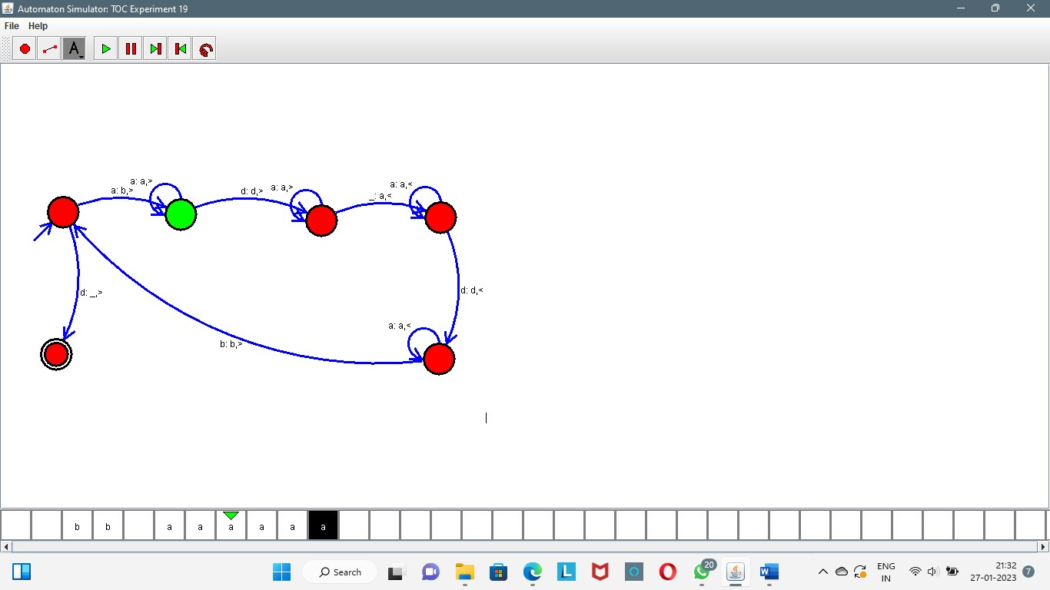

**RESULT:** TM is designed & performed addition by using a simulator.